**Deadline: 23:59, March 6th, 2020 (Friday)**

**CS 4296/5296 Spring 2020 Assignment 1 (**2 questions, 5 marks)(Updated on March 2rd)

**Remember to stop or terminate your instances after measurement**

**Note: Please choose Ubuntu 18.04 when creating EC2 instances for assignment 1.**

1. (2 marks) Measure EC2 **CPU** and **Memory** performance

Implement measurement on general purpose **m4.large and m4.xlarge** linux instances, respectively, and find the performance differences among these instances. Does the performance of EC2 instances increase commensurate with the increase of the number of ECUs* and memory resource? In order to answer this question, you need to complete the following table by filling out blanks with the measurement results corresponding to each instance type.

**CPU performance measurement command:**

sysbench --test=cpu --cpu-max-prime=10000 --num-thead=4 run

**Memory performance measurement command:**

sysbench --test=memory --num-threds=4 --memory-total-size=10G --memory-poer=write --memory-scope=global run

|  |  |  |
| --- | --- | --- |
| Size | CPU performance -- Events per second | Memory performance -- transfer speed MB/s |
| **m4.large** | 1394.49 | 6432.91 |
| **m4.xlarge** | 3081.47 | 10240.00 |

* Region: US East (N. Virginia)



**Measurement Analysis:**

1. (3 marks) Measure EC2 **network** performance.
   1. The metrics of network performance include **TCP bandwidth (throughput)** and **RTT** (Round Trip Time). Within the same region, what network performance is experienced between instances of the same type and different types? In order to answer this question, you need to complete the following table. You can use the instances in **US East region**, and specify the TCP window size to 256K for bandwidth measurement. (Please use **private IP** to measure the performance)

|  |  |  |
| --- | --- | --- |
| Type | TCP bandwidth (Mbps) | Average RTT (ms) |
| t2.micro - t2.micro |  |  |
| t2.micro - m4.large |  |  |
| t2.micro - m4.xlarge |  |  |
| m4.large - m4.large |  |  |
| m4.large - m4.xlarge |  |  |
| m4.xlarge- m4.xlarge |  |  |

-

1. What about the network performance (bandwidth) with different window sizes? In order to answer this question, you can use two t2.micro instances, and vary the window size to measure the performance, and complete the following table. (Please use **private IP** to measure the performance)

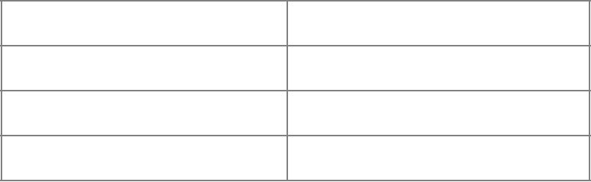

|  |  |
| --- | --- |
| Window Size | TCP bandwidth (Mbps) |

128K

256K

512K

1. What about the network performance with one server and multiple clients? In order to answer this question, you need to set one server, and multiple clients. After initiating the listening mode on the server, run throughput measurement command on all clients **simultaneously** and record the bandwidth in the following table. Window size is set to 256K. (Try to use batch processing to run the commands simultaneously). (Please use **private IP** to measure the performance)

|  |  |  |  |
| --- | --- | --- | --- |
|  | Client1 | Client2 | Client3 |
| Number of Clients | TCP bandwidth (Mbps) | TCP bandwidth (Mbps) | TCP bandwidth (Mbps) |
|  |  |  |  |
| 2 |  |  | N/A |
|  |  |  |  |
| 3 |  |  |  |
|  |  |  |  |

For RTT, ping from different instances (clients) to the same instance (server) **simultaneously**, and complete the following table.

|  |  |  |  |
| --- | --- | --- | --- |
|  | Client1 | Client2 | Client3 |
| Number of Clients | Average RTT (ms) | Average RTT (ms) | Average RTT (ms) |
|  |  |  |  |
| 2 |  |  | N/A |
|  |  |  |  |
| 3 |  |  |  |
|  |  |  |  |

1. Is the network performance consistent over time? In order to answer this question, you need to complete the following table.

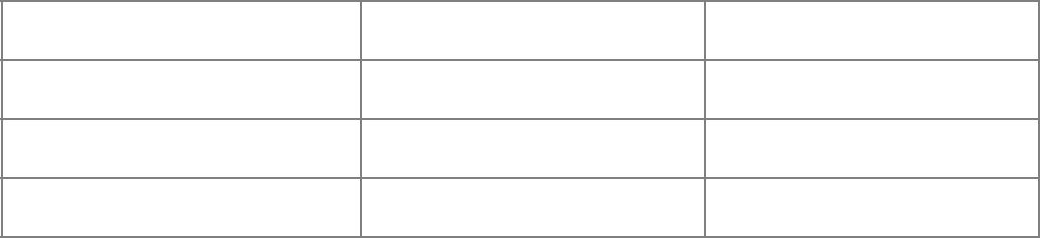

|  |  |  |
| --- | --- | --- |
| Time (HKT) | TCP bandwidth (Mbps) | Average RTT (ms) |

Morning (~10:00am)

Afternoon (~4:00pm)

Evening (~10:00pm)

* Region: US East (N. Virginia); Instance Type: t2.micro - t2.micro

**Remember to stop or terminate your instances after measurement**

1. Open-ended question: In the above sub-questions, you have measured network performance in different scenarios. Observe the values in each table, and try to explain why the network performance varies in different scenarios?



1.

2.

3.

4.

**Submission Instructions**

The answer of these questions should be submitted as a PDF file to Canvas before deadline. Your filename should be **4296-Assignment-1-YourName-StudentNo.** or **5296-Assignment-1-YourName-StudentNo.**, e.g., 5296-Assignment-1-AliceWang-12345678.pdf.